OPC UA MQTT - Name of “object types” issue

Description if issue

A MQTT Subscriber that receives dataset messages that are derived from a DataSetClass, identified with DataSetClassId, needs a way to discover information about the DataSetClass like Name and Description.

Use case

Typical use case in our domain is to represent Types, e.g., complete or subset of OPC UA Object Types, as DataSetClass. E.g., a Motor object type can be described as a DataSetClass that describes the fields of a Motor Object.
Instances of the Motor object type, e.g., OPC UA Objects, is mapped to DataSets published by a DataSetWriter.
On the topic tree DataSet messages for Motor objects is published on a topic representing the Motor Instance. E.g., Motor1. The metadata topic contains the DataSetMetaData that describes the Motor instance. E.g., with name, description and field properties that describe the Motor Instance.
The Set of Fields and their types are all “derived” from the DataSetClass that represents the Motor Type. I.e., the metadata describes fields and their datatypes that are common for all DataSetMetaData documents published for Motors.
The DataSetClassId is set to the Id that represents the Motor Type.

With this scenario, it’s logical to use the DataSetMetaData name field to represent the Motor instance.

The Problem
The Problem statement is how can a Subscriber get the DataSetMetaData that is identified by the DataSetClassId. I.e. the DataSetMetaData that represents the Motor Type.

There are some inconsistencies in the 1.05.03. RC1 specification regarding handling of DataSetMetaData:
5.2.3 addresses how a subscriber can get the metadata. With the topic tree metadata is now published on the metadata topic for each DataSet. But the topic tree does not contain the metadata for DataSetClasses.
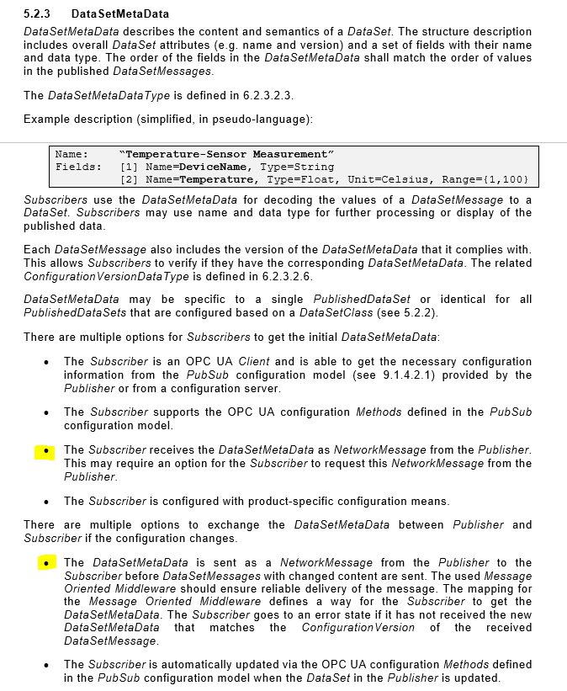

Section 5.2.2 describes the DataSetClass and the template concept where the DataSetMetaData is identical for all PublishedDataSets based on this class.
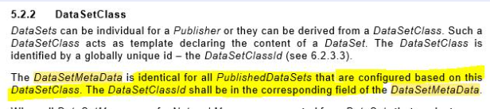

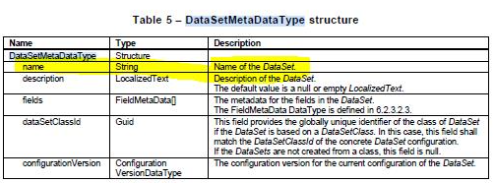

In the Description of the DataSetMetaDataType the Name field is described as the Name of the DataSet. I.e. not the DataSetClass name.
